CSP初赛模拟考试·第十六套
1.在 PC 机中，PENTIUM(奔腾)、酷睿、赛扬等是指( ).
A. 生产厂家名称
B. 硬盘的型号
C. CPU 的型号
D. 显示器的型号
2.1TB代表的字节数是( ).
A. 2的10次方
B. 2的20次方
C. 2的30次方
D. 2的40次方
3.
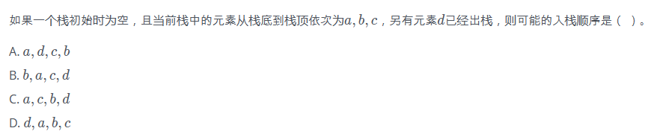
4.
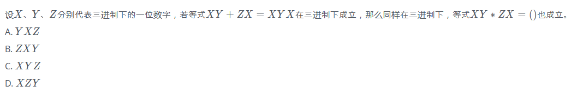
5.一棵具有5层的满二叉树中结点数为( )。
A. 31
B. 32
C. 33
D. 16
6.
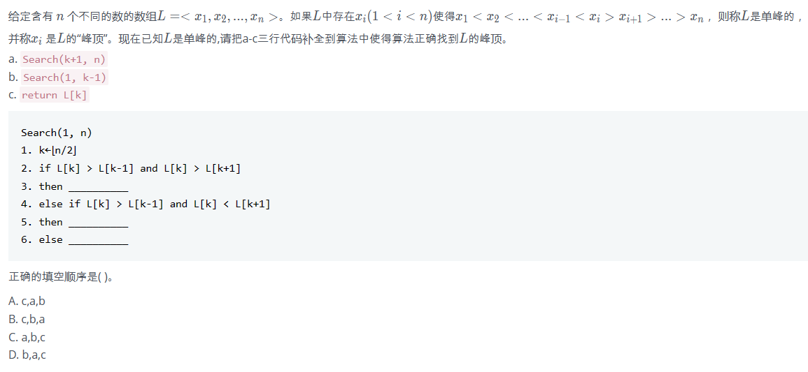
7.
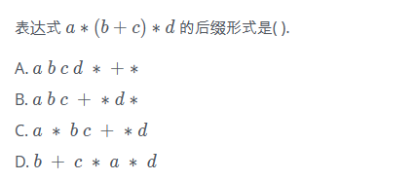
8.现有一段文言文，要通过二进制哈夫曼编码进行压缩。简单起见，假设这段文言文只由4个汉字“之”、“乎”、“者”、“也”组成，它们出现的次数分别为700、600、300、400。那么，“也”字的编码长度可能是( ).
A. 1
B. 2
C. 3
D. 4

9.
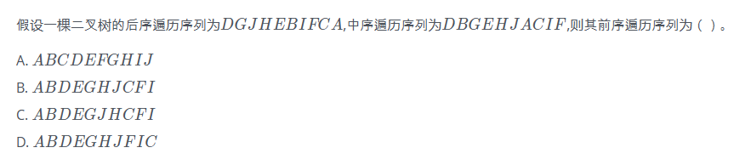
10.
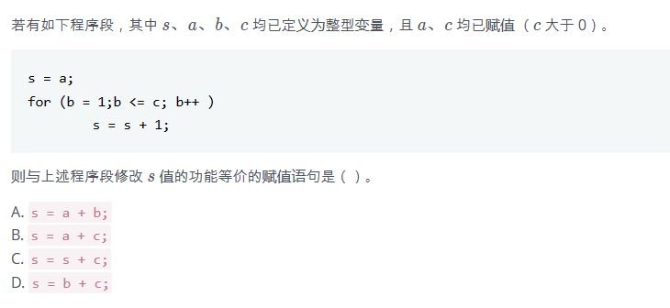
11.
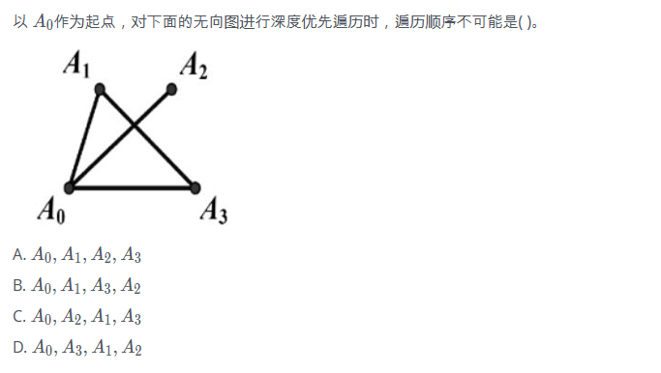
12.
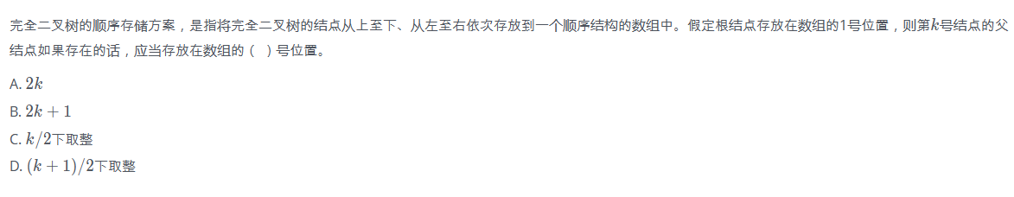
13.
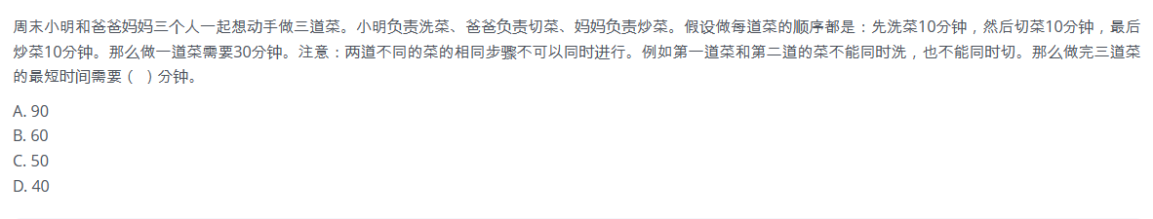
14.有向图中每个顶点的度等于该顶点的( )。
A. 入度
B. 出度
C. 入度和出度之和
D. 入度和出度之差
15.
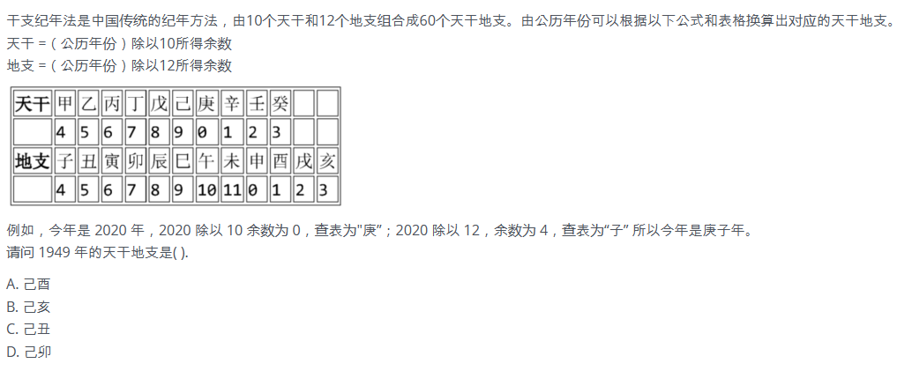
- 填空
1 #include
2 using namespace std;
3
4 int n;
5 int d[1000];
6
7 int main() {
8 cin >> n;
9 for (int i = 0; i < n; ++i)
10 cin >> d[i];
11 int ans = -1;
12 for (int i = 0; i < n; ++i)
13 for (int j = 0; j < n; ++j)
14 if (d[i] < d[j])
15 ans = max(ans, d[i] + d[j] - (d[i] & d[j]));
16 cout << ans;
17 return 0;
18 }
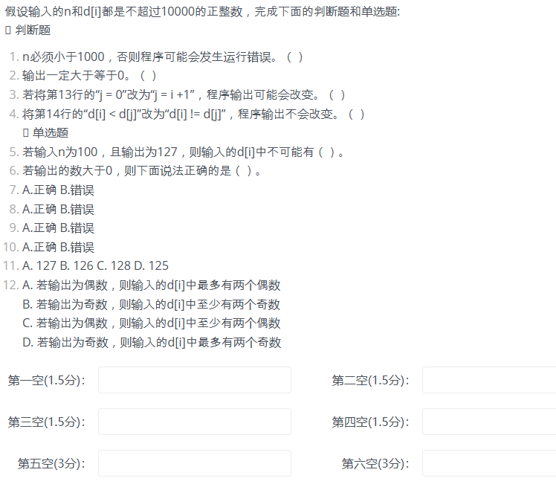
- 填空
1 #include <iostream>
2 using namespace std;
3 const int maxn = 10000;
4 int n;
5 int a[maxn];
6 int b[maxn];
7 int f(int l, int r, int depth) {
8 if (l > r)
9 return 0;
10 int min = maxn, mink;
11 for (int i = l; i <= r; ++i) {
12 if (min > a[i]) {
13 min = a[i];
14 mink = i;
15 }
16 }
17 int lres = f(l, mink - 1, depth + 1);
18 int rres = f(mink + 1, r, depth + 1);
19 return lres + rres + depth * b[mink];
20 }
21 int main() {
22 cin >> n;
23 for (int i = 0; i < n; ++i)
24 cin >> a[i];
25 for (int i = 0; i < n; ++i)
26 cin >> b[i];
27 cout << f(0, n - 1, 1) << endl;
28 return 0;
29 }
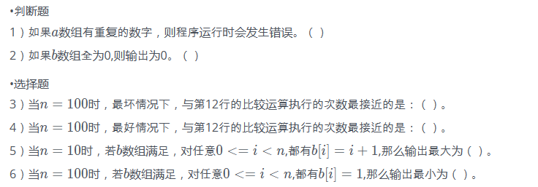
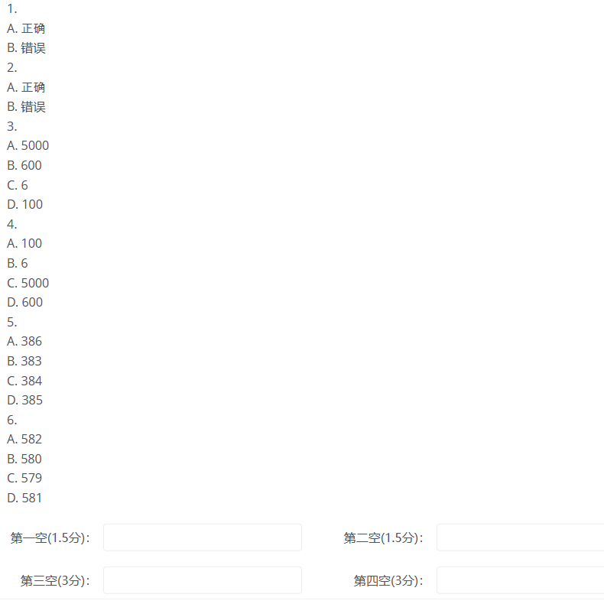
- 填空
1 #include<bits/stdc++.h>
2 using namespace std;
3 #define MOD 19260817
4 #define MAXN 1005
5 long long A[MAXN][MAXN]={0}，sum[MAXN][MAXN]={0};
6 int n, m, q;
7 int main(){
8 A[1][1]=A[1][0]=1;
9 for(inti=2;i <= 1000; i++) {
10 A[i][0]=1;
11 for(int j = 1; j <= i; j++)
12 A[I][j]=(A[i-1][j]+A[i-1][j-1])%MOD;
13 }
14 for(int i =1;i <= 1000; i++)
15 for(int j=1;j<=1000;j++)
16 sum[i][j]=(sum[i-1][j]+sum[i][j-1]
17 -sum[i-1][j-1]+A[i][j]+MOD)%MOD
18 int q;
19 cin >> q;
20 while(q--){
21 int n, m;
22 cin >> n >> m;
23 cout << sum[n][m] << endl;
24 }
25 return 0;
26 }
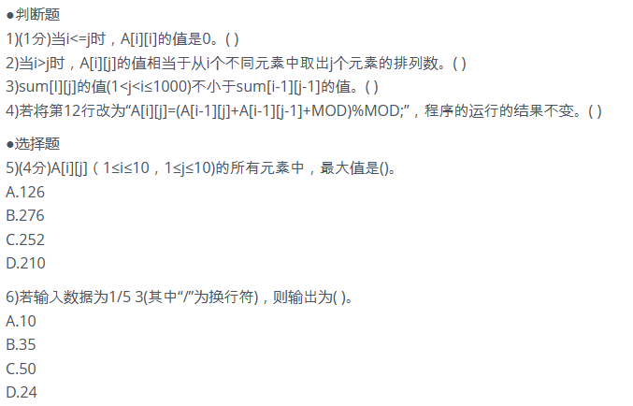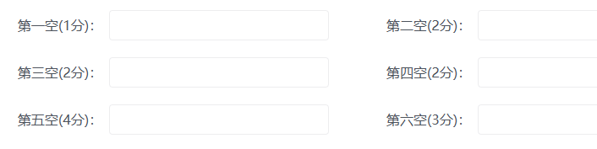
19.
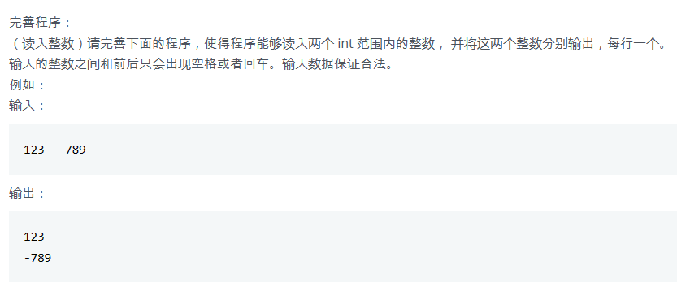
#include <iostream>
using namespace std;

int readint(){
int num = 0; // 存储读取到的整数
int negative = 0; // 负数标识
char c; // 存储当前读取到的字符
c = cin.get();
while ((c < '0' || c > '9') && c != '-')
c = ①;
if (c == '-')
negative = 1;
else
②;
c = cin.get();
while (③){
④;
c = cin.get();
}
if (negative == 1)
⑤;
return num;
}
int main()
{
int a, b;
a = readint();
b = readint();
cout << a << endl
<< b << endl;
return 0;
}
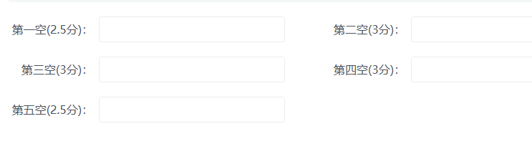
20.填空
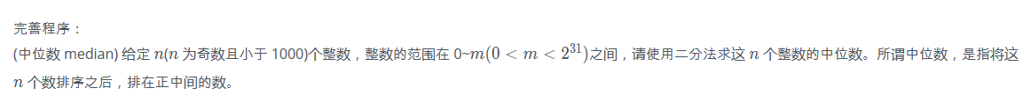
#include <iostream>
using namespace std;

const int MAXN = 1000;
int n, i, lbound, rbound, mid, m, count;
int x[MAXN];

int main()
{
cin >> n >> m;
for (i = 0; i < n; i++)
cin >> x[i];
lbound = 0;
rbound = m;
while (①)
{
mid = (lbound + rbound) / 2;
②;
for (i = 0; i < n; i++)
if (③)
④;
if (count > n / 2)
lbound = mid + 1;
else
⑤;
cout << mid << " " << lbound << " " << rbound << " " << count << endl;
}
cout << rbound << endl;
return (0);
}
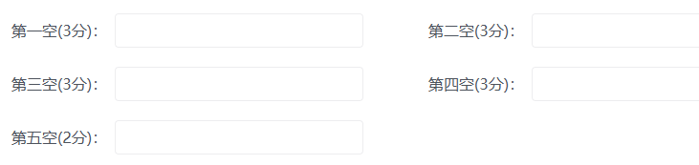

1.
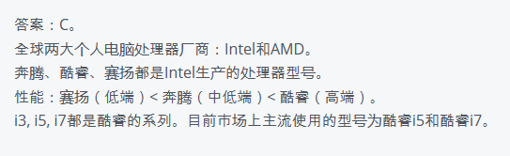
2.
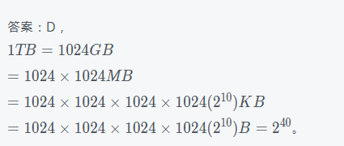
3.
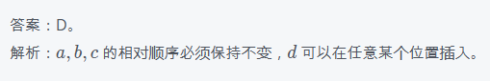
4.
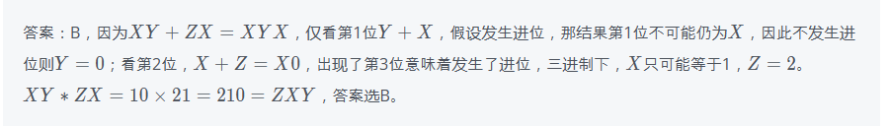
5.
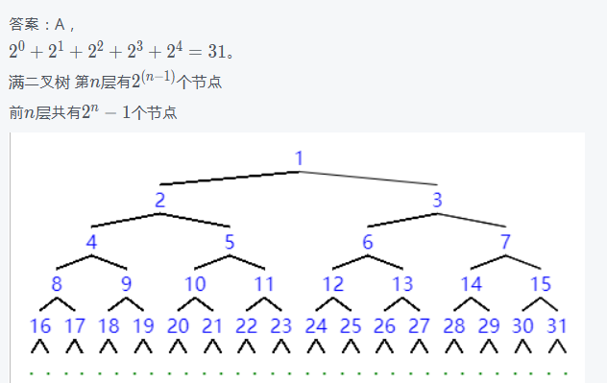
6.
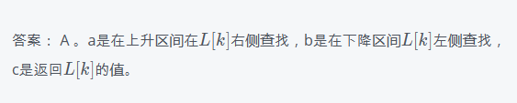
7.
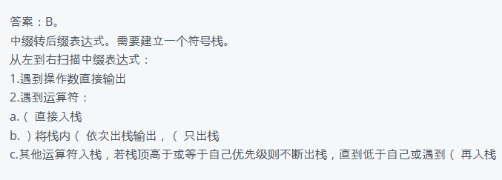
8.
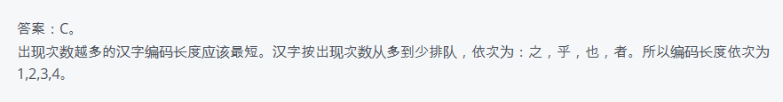
9.
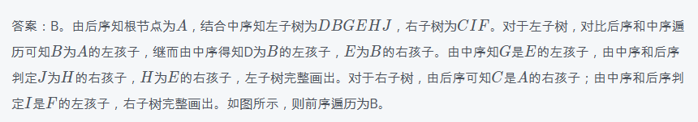
10.
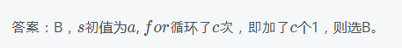
11.
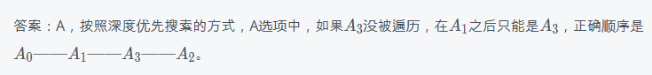
12.
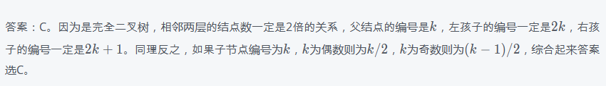
13.
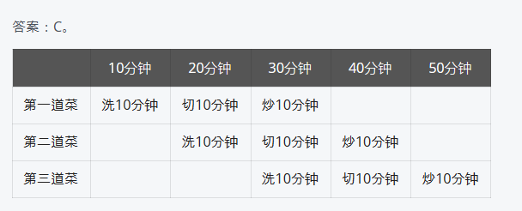
14.
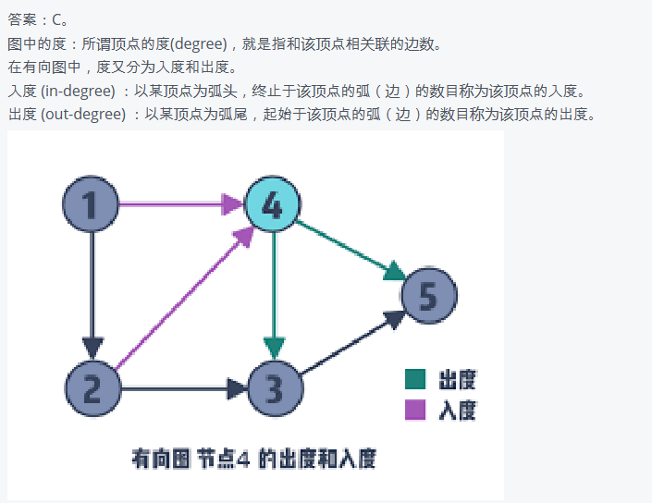
15.
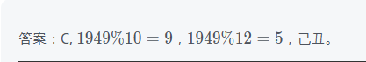
16.
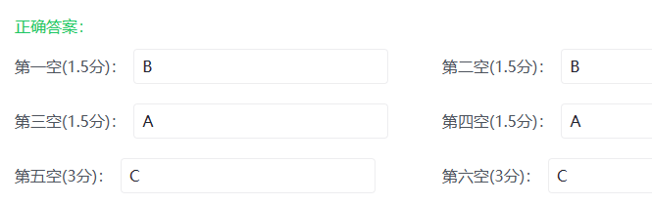
17.
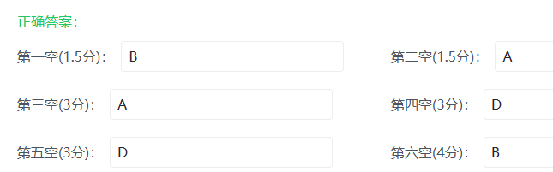
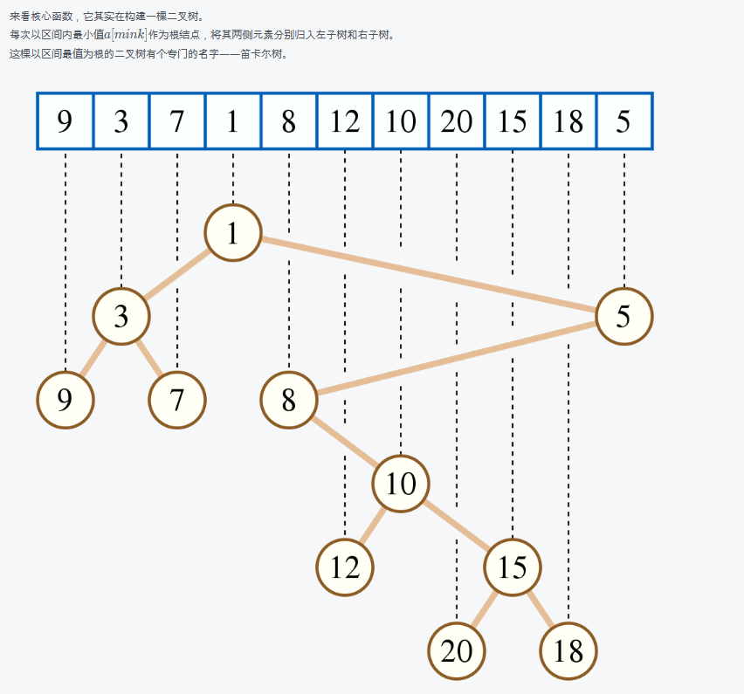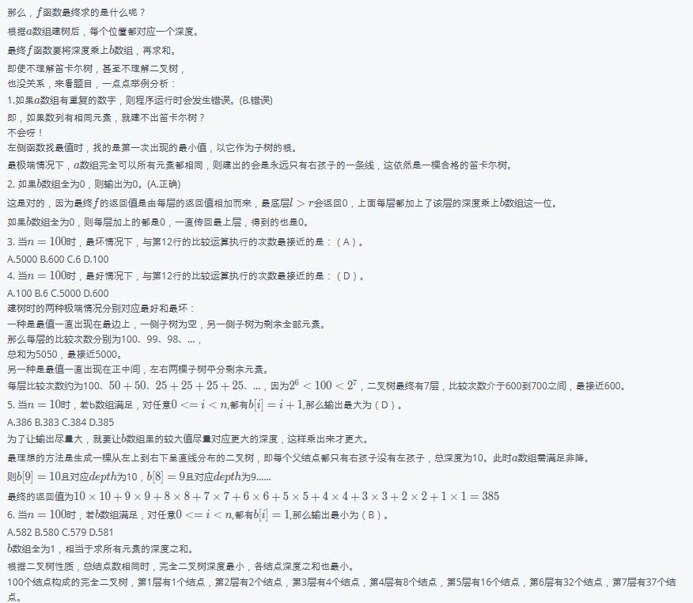
18.
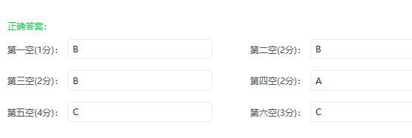
19.
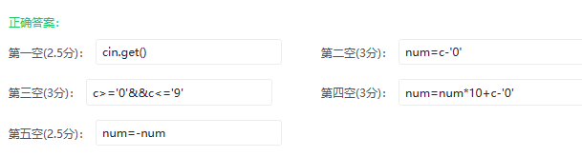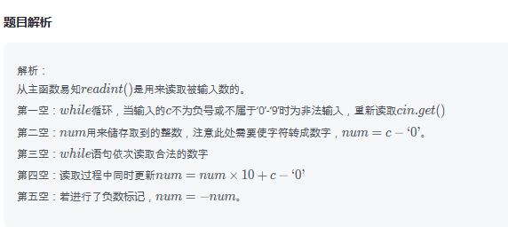
20.
